1. Name – Value Pair

Là Key – Value

Ví dụ: let name = “thanh hai”;

1. Object

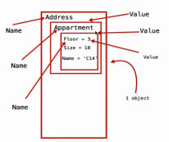

Ví dụ:

Info = {

Name: {

Firstname: “Tran”,

Middlename: “Viet”,

Lastname: “Hai”

},

};